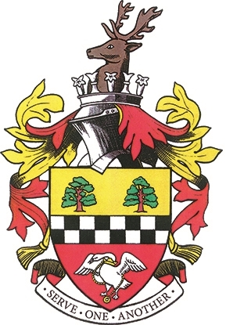

Nominate a business or retail outlet that makes a positive difference to Chesham and its community and they could win a specially engraved trophy. The closing date for applications is 11th March 2015.
Please return forms to Kathryn Graves, Chesham Town Council, Town Hall, Chesham, HP5 1DS or email to policy@chesham.gov.uk
Section One – Business/Retail Outlet Being Nominated
Name of Business

Type of Business

Business Address

Telephone Number & Email

Name of Main Contact

Section Two – Reason for Nomination
Please tell us what the business has done to deserve the Business Award, including the length of time the business has been working for the community. Please continue on a separate sheet if needed. You may attach photos and press cuttings to support your nomination.

CHESHAM TOWN COUNCIL MAYORAL AWARDS 2017
THE BUSINESS AWARD APPLICATION FORM
Section Three – Registration

Section Three – Registration
Please provide your details so that we may contact you to find out more information if required.

Proposer’s Name

Proposer’s Address

Proposer’s Phone Number
and Email

Proposer’s Signature

Date

The Business Award Rules
- The business/retail outlet must have made a positive contribution to the community of Chesham through involvement in either community projects/causes, environmental activities or charitable/voluntary work.
- Charities/not-for-profit organisations are not eligible for this award, but project groups can be nominated for the People’s Award.
- The business/retail outlet must have premises located in Chesham.
- A business can nominate itself for the award, or be nominated by individuals or other companies.
- The closing date for nominations is Monday 11th March 2017.
- The award is a certificate and engraved trophy, donated by Chiltern Chamber.
- The winner will be presented with the award at the Annual Town Meeting, held at Chesham Town Hall on Thursday 11th May 2017.
- If you have any questions, please contact the Town Hall on 01494 583798 or email policy@chesham.gov.uk.
- All nominees will automatically be entered into the Bucks Examiner ‘Pride of Bucks’ Awards and the information submitted on this form by you will be passed to the Bucks Examiner.

Chesham Town Council gathers and processes information in adherence with the Data Protection Act (1998). The information we hold will only be used for the purpose it was obtained.

